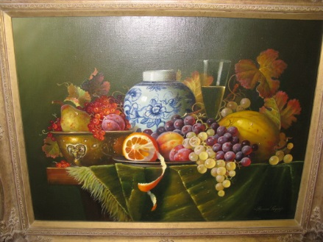
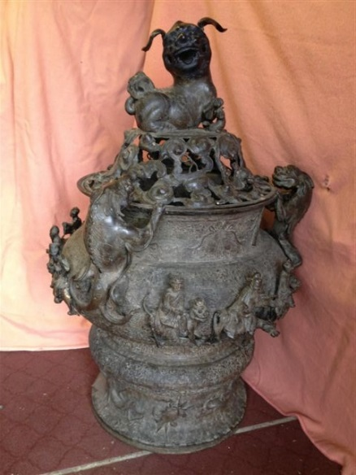
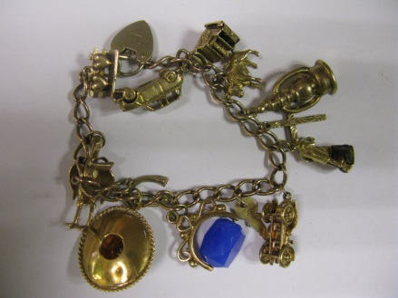
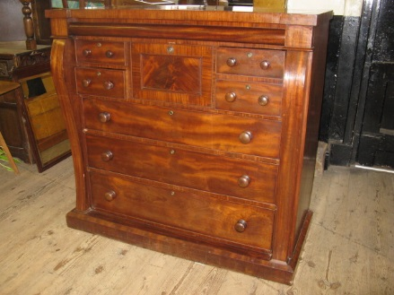

ITEMS ON VIEW
WED 16TH OCTOBER
10.00 AM – 6.00PM
and morning of sale

THURSDAY 17TH OCTOBER 2013
AT
10.30 AM

AUCTION SALE

on behalf of local estates and others of:-

STUNNING CHINESE BRONZE KORO, HEIGHT 44”; ANTIQUE & MODERN FURNITURE; CLOCKS; 20c “STILL LIFE” OIL ON CANVAS by RAYMOND CAMPBELL; PICTURES and PRINTS incl BOTTICELLI; ELECTRIC incl GUITARS and LCD T.V.s; COLLECTABLE CHINA and GLASS incl ROYAL ALBERT and DENBY COLLECTIONS, VINTAGE ORIENTAL, etc; GOLD and SILVER; BANKNOTES and COINS incl 1947; WHITE £5 NOTE; COLLECTABLES incl 19C FANS and ORIENTAL IVORY; CYCLES; MISC; 1999 FORD FIESTA CAR ( to be sold at 1pm)

At the Mart Saleroom, Roman Bank, Skegness, Lincs, PE25 2SL

AUCTION SALE
THURSDAY 24TH SEPTEMBER 2020 AT 9.30 AM
On behalf of local estates 362 Lots of:-

GOOD SELECTION OF BOOKS, MANY 19c incl 1813 ‘THE HOUSEKEEPERS RECEIPT’, MAGAZINES, MUSIC, LINCS, EPHMERA; VICTORIAN STAMPS; POSTCARDS; CHINA and GLASS incl BESWICK DOGS, ROYAL, MEASHAM, LUSTRES; VINTAGE TOYS, JIGSAWS; MECCANO; CAST FIGURES and VEHICLES; SCALE MODEL SUPERCARS and TRACTORS; MISC and COLL incl SHIPS, TOOLS, TINS, BOXES, MOWER, ANIMALS, FLAGS, CAMERAS, 19C NEEDLEPOINTS, METRONOME, GERMAN OFFICERS CAP, LINCS REG SWAGGER STICK, CANES; PICTURES incl 1990 LES CLARKE PRINT, BUTTONS, NAÏVE OILS, RAILWAY; MIRRORS; COINS incl SILVER; BADGES; JEWELLERY; WATCHES; SILVER; GOLD incl ROTARY WATCH; HOUSEHOLD ELECTRICALS; CLOCKS; ANTIQUE and MODERN FURNITURE incl ERCOL; MINI COOPER MOTOR CAR (TO BE SOLD AT 12:45PM)

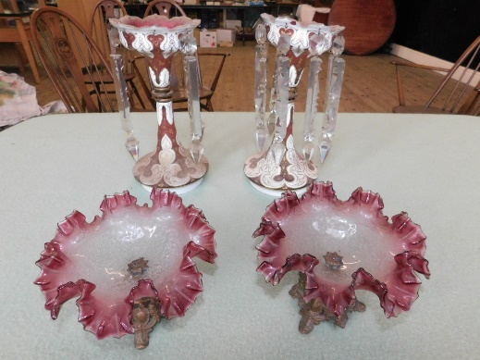
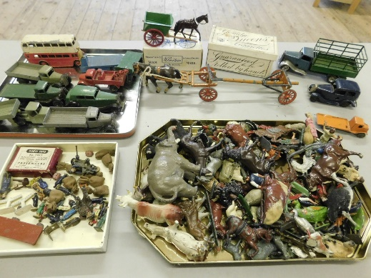
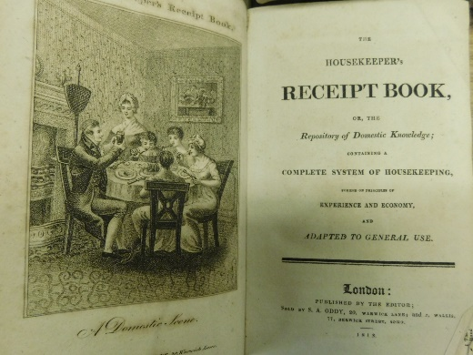

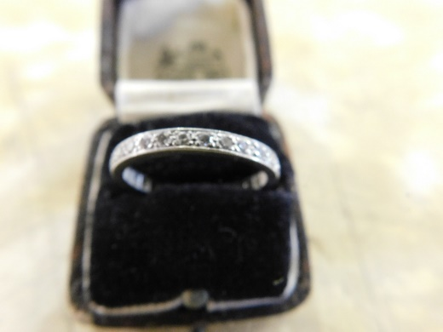
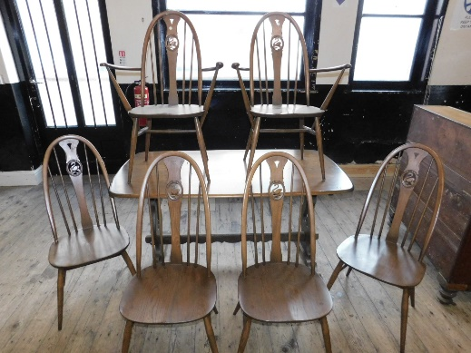
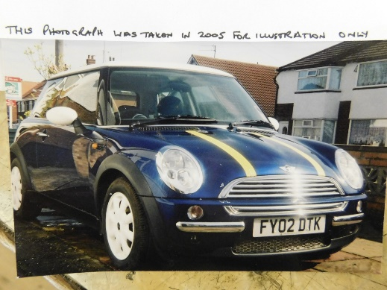

ITEMS ON VIEW:-
TUESDAY 22ND SEPTEMBER, 2020 - 10.00am to 5.00pm
WEDNESDAY 23RD SEPTEMBER, 2020 – 10.00am to 5.00pm

The Mart Sale Room, 32 Roman Bank, Skegness, Lincs, PE25 2SL
http://www.hunters.com/skegness-auctions jonathan.booth@hunters.com 01754 766061

C0R0NAVIRUS ( COVID-19 )

AUCTION SALEROOM PROCEDURES

IN LINE WITH THE GOVERNMENT’S SAFETY GUIDELINES ALL CLIENTS ATTENDING ‘THE MART SALEROOM, SKEGNESS’ WILL BE REQUIRED TO ABIDE WITH THE FOLLOWING MEASURES

- On entering the building by the Roman Bank entrance ‘only’ all clients will be required to wear a Face Mask and protective Gloves for the full duration of their visit, they will then be required to exit the building via the stairs into the Car Park, with the exception of people with mobility issues who must inform a member of staff who can assist them.
- View days will be held on the Tuesday and Wednesday prior to Thursday’s Auction, commencing at 10.00am and finishing at 5.00pm on each day. Viewing of the items is by appointment only and all clients must book their time slot with the Auction Department, telephone 07917 186527 to allow the safe management of Social Distancing within the room.
- The Auction will commence on the Thursday at a revised time of 9.30am and there is to be NO viewing before the Auction. Due to Safe Distancing measures we can only offer a very limited amount of seating on Auction day so we shall encourage clients to leave us with commission bidding forms, which we shall deal with confidentially. Anyone wishing to attend on Auction day must first contact the Auction Department, telephone 07917 186527 to reserve a seat, this can only be done at the discretion of the Auctioneer.
- At all times whilst in the Saleroom or waiting to enter we shall require all clients to abide by the applicable social distancing measures which we shall clearly display.
- The Auction will commence at 9.30am and will be limited to 350-400 Lots, we therefore anticipate that it will finish no later than 1.00pm. No lot shall be paid for or removed prior to 1.30pm on Auction Day to allow the Pay Office Staff the necessary time to have the bills ready to avoid any queueing. We would prefer payment by Card if possible. Please be patient whilst waiting to collect your items as we can only deal with one client at a time.
- Anyone wishing to remove their purchased items after Auction Day must contact the Auction Department, telephone 07917 186527 to make the necessary appointment.
- On entry to the Saleroom all clients will be required to sign and confirm they are symptom free, not self isolating, have not been in a high risk area for the last 14 days. They are also required to leave their telephone number should they need to be contacted through track and trace regulations.

THANK YOU FOR YOUR CO-OPERATION

HUNTERS TURNER EVANS STEVENS AUCTION SALE
THURSDAY 24th SEPTEMBER, 2020-commencing 9.30AM

LOT No. DESCRIPTION

BOOKS, RECORDS, STAMPS and POSTCARDS
- Motoring Books
- Motoring Books
- Motor Racing Scrapbooks, photos and Motorsport Videos
- Steam Railway Books
- Steam Railway Books
- Steam Railway Books
- Lincolnshire Books
- Lincolnshire Ephemera
- Skegness and Lincolnshire Ephemera incl. Lincs Roadcar 1933 Timetable
- Lincolnshire Maps
- Vintage Pictorial Pamphlets of English Stately Homes
- Landranger OS Maps, etc.
- Atlases, Road Maps, Geography Books, etc.
- Electrical Engineering Books
- Educational Books
- 4 Autograph Books
- Children’s Books
- Vintage Children’s Books incl. Domini Doormouse
- Volumes 1 – 8 of 1907 Harmsworth Self Educator Books
- Sheet Music – mostly Organ
- Sheet Music – mostly Organ
- Sheet Music – mostly Organ
- Cookery Books incl. Mrs. Beeton’s 1901 Edition
- Books and Magazines incl. Mrs. Beeton Everyday Cookery and 1961 Honey Magazine
- Assorted vintage Novels
- Assorted vintage Novels
- Poetry and Prose incl. Milton, Wordsworth, Shakespeare, Longfellow, etc.
- 17 Charles Dickens Novels most being part of a series by Hazell, Watson & Viney
- A large quantity of vintage Model Engineering Magazines
- A large quantity of vintage Meccano Magazines
- 4 vintage Model Shipping and Engineering Catalogues incl. Bond’s, Bassett – Lowke,
Stuart Models and Kennion Bros.
- 1936 Bibby’s Annual in excellent condition
- 1937 George VI Coronation flier, Eliz II Wedding Gift list, etc.
- 1951 Festival of Britain Battersea Park Pleasure Gardens guide, etc.
- 1856 White’s Directory of Lincolnshire, requiring attention
- 1787 Religious week preparation, 1873 Memoirs of Billy Bray, Corner Cup’d, etc.
- 1813 ‘The Housekeeper’s Receipt’ Book
- A hand written Book by F. Norris in 1781 containing 132 Food and Drink Recipes
- 1859 ‘The Scottish Chiefs’ by Miss Jane Porter with 1867 ‘Beyond The Mississippi’ by
Albert D. Richardson
- Late 1800’s Volumes 1 and 11 of ‘The Natural History of the Sacred Scriptures and
Guide to General Zoology by Bicknell, each with around 300 coloured engravings
- LP’s, Singles and CD’s
- Stamps, Stamp Albums, Tea and Cigarette Cards
- Cigarette Cards
- Album of vintage Stamps incl. GB with many Victorian, Empire, USA, France,
Germany and Colonies
- Album of Lincolnshire Postcards
- 5 Albums of tourist Postcards
- 5 Albums of tourist Postcards
- 4 Albums of tourist Postcards
- 4 Albums of tourist Postcards
CHINA and GLASSWARE
- Denby and other coffee Mugs
- Majolica Jardiniere, treacle glazed Toby Jug, Earthenware Jug, etc.
- Small china coffee ware
- Royal commemorative Mugs
- Royal commemorative Plates and Dishes
- Royal commemorative Mugs
- Modern Oriental china
- China celebrating people and places of interest
- 7 Bradex Wedgwood and other Country Farming wall plates and slates
- Dog related items comprising Print, Plates and Ornaments
- Decorative mid 20c china Pots, Baskets, etc
- 5 Bradex and other WWII Warplane Plates
- 2 vintage green glass Baskets and Fish Dish, blue glass Jug and Ball
- 3 Preserve Pots, Torquay Dis and Wade Log
- Plates and Mugs celebrating vintage modes of Transport
- China Rabbits, Monkeys, Birds, etc.
- Interesting china incl. a pair of Lobster footed Dishes
- Jugs and Teapots
- 5 glass Dishes incl. Carnival, blue and clear
- Cut glass and Bohemian glass Vases
- Figurines
- 5 pieces of Wedgwood blue Jasperware
- Robin ornaments incl. Art glass Paperweight
- Small china Boxes and 2 small Clocks
- 11 pieces of Wedgwood green Jasperware
- Cut glass and pressed glass fruit Bowls
- 4 china Teapots with a London coffee Mug
- 4 pieces of Royal commemorative china incl. Victoria, George V and George VI
- Frog Ornament and other small china
- Pyrex coffee Pot, Crown Devon, Carlton, Wade and Sauce Pots
- Coloured glassware and Paperweights
- China Horse with plastic Drey
- 2 Staff china Dogs and 2 damaged recumbent Calves
- Wall hanging plaster Ducks and Terns
- Vintage blue glass Vases and Lamp
- Glass Paperweights incl. Prisms
- Attractive fruit patterned Staffordshire table ware ‘Autumn Fayre’ compr. Teapot,
Jug, 4 Plates, 2 side Plates, 4 Bowls and 2 Cups and Saucers
- Worcester ‘Richard MacNeil’ design Chicken decorated Teapot, etc
- Unusual stretched Coca Cola Bottle with 2 Glasses
- Large blue Squirrel handled Sylvac Jug with similar style Lion posy holder
- 5 china Bells incl. Poole, Royal Albert Cup and Saucer, etc.
- Stylised china Mice in Cheese, Hats, Barrels, etc.
- Vintage blue and white china Bowls and Stands, mostly repaired with a 19c
Wedgwood footed Fruit Bowl with a small chip to the rim
- Glass Cake Plates, Bowls, etc.
- European and GB majolica style Plates and Vases, mostly green
- Batemans Pub water Jug, ceramic White Horse bottle Pourer and damaged Orlwite
Biscuit cone server
- Wicker Picnic Hamper with Empire ware China
- Willow Pattern Plates, Bowls and Platters incl. Wedgwood Fallow Deer
- Four 19c hand painted Bowls and covered Soup Tureen
- Dutch lidded Pot, Butter Dish with cow handled lid, etc.
- Murano glass Bird and other Paperweights
- Delft china Figures, Clogs, etc.
- 19c Oriental hand painted china Bowl
- A large quantity of Nursery china incl. Keele Street, Meakin, etc.
- Boxed Wade baby Tortoise set, 13 Whimsies, Tortoise Ashtray, etc.
- Studio Cat in the style of Sarah Winstanley
- Melba ware Old English Sheepdog and Collie Dogs
- 2 black hand painted Cats with balls inspired by Beswick
- Beswick Fox and one similar
- Beswick Spaniel
- 3 Wade Disney ‘Lady and the Tramp’ Whimsies, etc.
- Beswick ‘Lochinvar of Lady Park’ Collie Dog and similar Collie Dogs
- Large Beswick ‘Lochinvar of Lady Park’ Collie Dog with a smaller Beswick version
- 4 Edinburgh Crystal ‘Thistle’ design Brandy Glasses
- A pair of tall Imari pattern Vases with ribbed bodies and flared rims
- Treacle ware Teapot and Kettle in typical Measham Barge ware decoration
Both having ancient damage
- A pair of vintage Cranberry frilled glass Bon – Bon Dishes on metal stands
- A pair of Victorian Pink and milky white glass Lustres, some droplets missing

VINTAGE TOYS, DIE CAST VEHICLES and MODEL RAILWAY
- Royal commemorative Jigsaw Puzzles
- Steam Railway and similar Jigsaw Puzzles
- Assorted Jigsaw Puzzles
- Assorted Jigsaw Puzzles
- Assorted Jigsaw Puzzles
- Assorted Jigsaw Puzzles
- Assorted vintage Toys and Games
- Assorted vintage Toys and Games
- Assorted vintage Toys and Games
- Foreign Dolls
- Cat and Leopard soft Toys
- 2 plastic USA articulated container Lorries
- Battery operated remote controlled Dog
- Scalextric Mini Racing Car Game
- Box of assorted vintage Meccano
- 2 Corgi die cast articulated Lorries, one being Eddie Stobart
- Vintage cut out wooden Animals, etc.
- 8 vintage cast Animals, Guardsmen and Telephone
- 6 vintage cast WWII War Planes with a Dinky Singapore Flying Boat
- Vintage Britains and other cast Farm Animals, Figures, Soldiers, etc.
- Vintage cast Well, Wheelbarrow, Oatsheaves, Churns, Fencing, etc.
- Vintage cast Britains No 40F Farm Cart and Horse in it’s original Box in mint
Condition together with a Britains Horse and Pole Cart requiring attention
- Triang Minic tin plate Truck, Austin Seven Car and similar Flatbed Lorry
- 9 Dinky Meccano Ltd Trackside Vehicles, Flatbed Lorries, Bus and Car
- 00 and larger Gauge model Railway Figures, Sacks and Signage
- 00 and larger Gauge scratch built wooden model Railway Buildings, Rolling Stock,
Trix TTR Track, etc.

SCALE MODEL SUPERCARS and TRACTORS
- 2 Xiong Sheng 1/18th scale red and silver Ferrari Cars
- 2 Tonka Polistil 1/16th scale Silver Mercedes Benz RW196 and White MGA
Twin cam Cars
- 1 Autoarc 1/18th scale Black Jaguar 120C Car
- 1 Pauls Model Art Minichamps 1/18th scale Sauber Petronas C22 F1 Racing Car
- 3 Maisto 1/18th scale White Audi R8 Le Mans – Sieger 2000, Silver Mercedes Benz
CLK – GTR and green Jaguar XJ 220 Cars
- 2 Burago 1/18th scale blue 1934 Bugati type ’59 and Silver Mercedes Benz SSK Cars
- 2 Burago 1/18th scale Yellow Alfa Romeo Spider 1932 and Purple 1934 Alfa Romeo
2300 Monza
- 2 Burago 1/18th scale Red 1957 Ferrari 250 Testarossa and 1965 Red Ferrari 250 Le
Mans Cars
- 2 Burago 1/18th scale Red 1987 Ferrari F40 and Red 1962 Ferrari GTO Cars
- 2 Burago 1/18th scale Blue Dodge Viper GTS Coupe and Red 1961 Porsche 356B Cars
- 2 Burago 1/18th scale Green 1961 Jaguar E and Silver Mercedes Benz 300SL Cars
- 2 Burago 1/18th scale Yellow 1997 Chevrolet Corvette CS and White 1988
Lambourghini Countach Cars
- 2 Burago 1/18th scale Red 1962 Ferrari GTO and Blue 2001 Mini Cooper Cars
- 1 Road Signature 1/18th scale Blue 1965 Shelby Cobra Daytona Coupe Car
- 2 Solido 1/16th scale Green 1964 Mini Cooper S and Blue new shape Mini Cars
- 4 Burago 1/24th scale Blue 1936 Bugati Atlantic, Silver 1954 Mercedes Benz 300SL
and 2 Black and Silver 1948 Jaguar XK 120S Cars, some requiring attention
- Universal Hobbies 1/16th scale Grey Ferguson TE 20 Tractor
- Universal Hobbies 1/16th scale Red Ferguson 35 Tractor
MISCELLANEOUS and COLLECTABLES
- Workshop Tools incl Soldering Iron
- Hozelok Hosereel with Lervia Sprayer
- Kitchen Containers
- Vintage Christmas Decorations
- Christmas Baubles
- Musical Jewellery Box and other Boxes
- Treen
- 2 Suede Coats
- Soda Syphon and Homeworks Storage Jar
- 3 boxed sets of Cutlery
- Pair of brass Candlesticks, small Handbell, etc.
- Wicker Picnic Basket and mini Shopping Basket
- Interesting Stones
- Resin and plastic Dogs
- Ornate brass Door stop
- 4 long necked Dutch inspired plaster and wooden Cats
- Wooden Candlesticks and brass Fire Irons
- Flat Iron and 2 cast Trivets
- 2 interesting metal ware fireside Cats
- 2 boxed Artist’s painting sets
- Wooden Lighthouses, Fishing Boats and Trawlers
- Rigged model of ‘Cutty Sark’ sailing Ship with a Ship in bottle
- Vintage Suitcase and Cash Tin
- Swiss style miniature wooden Cottages
- Reclaimed oak Melon Bulb Posts, etc.
- 4 sections of interesting timber Planking
- Garden Tools
- Miniature Oak Barrel on stand, requiring attention
- Boxed Stanley Combination Plane, steel bodied smoothing Planes, Tenon Saws, etc.
- 2 T G Green style Mixing Bowls with a stoneware Pippin
- A series of 3 graduating brown vintage Suitcases
- Tortoiseshell style Dish and 2 travelling Coat Hangers in a skin case
- Tortoiseshell style grooming ware incl. brush set
- Vintage oak ‘The Gurney’ Invalid bed back Rest
- Plaster Elephant and wooden Lion Bookends, Lions require attention
- Large quantity of red clay seedling Pots
- Vintage Tins
- Wicker Shopping Bsket
- Galvanised Tin Bath and Buckets
- 3 Oil Lamps
- Buttons
- Wooden twin handled Dish
- Misc. interesting items incl. Borjois Compact, Jonny Figure, Esso Blue Key Ring, etc.
- Misc. interesting items incl. Compacts, Cigarette Cases and Lighters
- Silver Plated Trophies, etc.
- Artificial Flowers, etc.
- Handbags
- Ladies Vanity Kit, etc.
- Wooden Coal Box
- Sea Shells
- Indian Brass ware and similar Pig Money Box
- Workshop Drawers of Fixings
- Wheelbarrow
- Honda Petrol Motor Mower
- Wooden Tool Drawers and contents
- Vintage Garden Tools
- 4 wooden Tressle Table Stands
- Modern hard shell Suitcase
- Set of 3 desktop Drawers
- Pair of Green Kat Binoculars in a case
- Cottons, Knitting Needles, etc.
- Buttons and Belt Buckles
- Resin Dogs and Sheep
- Resin Dogs and Sheep
- Fiddle hndle and other Cutlery
- Green enamelled and brass Kitchen Beam Scales and brass bell style weights
- Minton vintage Wall Tile plus one other
- Minton Hollins and Co vintage Sepia Wall Tile
- Tin Trunk
- Tin Pawn Brokers Balls
- Wooden Trunk
- Union Jack cotton Flag on stick
- 2 Union Jack cotton Flags on sticks
- Mahogany Tea Caddy with a smaller mahogany inlaid Box
- Mahogany Jewellery Box with hinged lid and lower drawer
- 2 leather music Satchels
- Vintage black Frister and Rossmann Sewing Machine in wooden case
- Kodak Instamatic 133 Camera with 2 flash cubes in it’s original box
- 2 Polaroid Instamatic Land Cameras
- Kodak VPK Model B Bellows Camera in it’s original box with a pair of Binoculars
- Vintage round pine Bread board and Utensils
- Interesting items incl. bone letter Knife, Eye Glass, Button Hooks, etc.
- Vintage miniature electric Desk Lamp with fitting for a Pygmy Light Bulb, on a
Bakelite base, missing the battery compartment, with a hide shade together with
a Steel and glass hanging Shade with Starburst decoration
- Vintage scallop shaped Ladies evening Purse
- 2 Cane Carpet Beaters
- 1960’s wire Magazine Rack with red ball feet and musical note decoration
- 5 pairs of vintage wire rimmed Spectacles some being gold plated
- A leather bound racing style Car Steering Wheel by JPC England
- 1880 Needlepoint of Heckington Shop with a further 1881 Needlepoint
- Ukelele in hard shell case
- Wooden Truncheon
- 19c Metronome by Maelzel Paquet
- Post War Bundeswehr West German Army Officers peaked Cap
- 3 lace adorned WW I greetings Cards from the front, a Somme Book, Cap Badge
and Military Spoon with No. 2787139 imprinted on the handle
- Lincolnshire Regiment Swagger Stick with crested silver plated Knop
- 3 Walking Canes, one with a silver end cap
- Ebonised Walking Cane with silver adornments plus one other
PICTURES and MIRRORS
- Assorted vintage framed images of Spilsby and surrounding area
- Assorted Naïve Oils on Board
- Assorted Naive Oils on Board
- Assorted Collages made from Buttons
- Assorted Collages made from Buttons
- Assorted Naïve rural Landscapes
- A series of 3 framed Naïve drawings of typical Dutch figures with 2 similar
Spoon stands
- 2 vintage Oils on Canvases with 2 watercolour River scenes
- 3 scenic Prints
- Hunting Oilograph, etc.
- 3 Steam Railway Prints
- Print of ‘Sir Nigel Gresley’ A4 Pacific Steam Locomotive after D L Noble
- A series of 3 Prints depicting the WW II Aircraft of the Battle of Britain Memorial
Flight after Dugold Cameron, 1988
- Lincoln Cathedral Watercolour and Print, Bawdsey Manor Print, etc.
- Print of ‘The Stepping Stones, Dovedale, Derbyshire Peak District after Rex Preston
- 2 Victorian large framed Photographs, one being a Bandsman together with a
Smaller Victorian family group
- A Print of a 1990’s Watercolour Montage by Les Clarke of Ilkeston depicting scenes
From Leicester, Coventry, Nottingham, Newstead Abbey and Lincolnshire together
with an image of an Inter City Train, being print no. 43 of 100
- 2 round metal framed Mirrors
- 2 modern Mirror framed Mirrors
- 2 pine framed Mirrors
COINS and BADGES
- 29 original style GB £1 coins in 13 different designs
- GB decimal Coin sets, etc.
- Predecimal GB Coins with a 50 Pfennig Coin
- 6 predecimal GB Coins incl. 1812 Birmingham Penny Token and 4 silver Coins
- 35 GB 1920-1946 half silver Three penny Coins
- 45 GB Pre 1920 full silver Three penny Coins
- Pin Badges incl. British Legion, Women’s Institute and Remembrance Day
- Silver Regimental Badge with Prince of Wales Vtrs’ Crest, MS Devonia Badge,
Edward VIII 1937 Coronation Badge, etc.
- Robertson’s Golly Pin Badges with 5 plaster Bandsmen, 2 having chipped bases
COSTUME JEWELLERY and WRISTWATCHES
- Crucifixes, Badges, Hatpins, etc.
- Assorted Jewellery incl. Pandora style
- Beaded Victorian Mourning Jewellery
- Vintage Murano Milafioi glass beaded Necklace
- Brooches, Necklaces, Earrings and Hatpins
- Necklaces, Hatpins and Brooches incl. Milifiori and Mourning beads and Brooches
- Gold effect Necklaces, Brooches, Earrings and Cufflinks
- Necklaces, Wristwatches and travel Clocks
- Assorted Wristwatches
- 8 vintage Wristwatches incl. Smiths
- Ladies and Gents Wristwatches incl. Junghans
SILVER
- Silver Identity Bracelet, etc.
- Silver bladed Penknife with Mother of Pearl handle
- 2 silver bladed Penknives with Mother of Pearl handles
- 2 silver propelling Pencils, pencil Cover and one other
- Silver Cake Slide, silver handled Fork and 3 silver Tespoons
- 2 Georgian silver Dessert Spoons
GOLD
- A pair of 9ct gold Earrings
- 9ct gold Wedding Band
- 22ct gold plain Wedding Band with an 18ct gold and platinum 5 diamond Ring
both have been cut
- An 18ct white gold and diamond Eternity Ring
- A Ladies Rotary Wristwatch in a 9ct gold case with a gold plated expanding strap, the
Swiss movement has been seen working

ELECTRICALS
- Dimplex oil filled Radiator
- Vax Air Reach cyclone vacuum cleaner
- Samsung 32 inch HD Television
- Bosch white Fridge-Freezer
- Beko white under counter Refrigerator
- Hotpoint Future white under counter Freezer
- Hotpoint Aquarius 7kg Washer-Drier
CLOCKS
- 2 reproduction Wall Clocks
- Brass miniature Carriage Clock by Swiza with a manual movement and one other
- SB Barometer, mini Weather House and Lighthouse style Wall Clock
- Vintage oak cased Westminster Mantel Clock, the front having Starburst decoration
FURNITURE
- Nest of 3 oak occasional Tables
- Square oak side Table
- 2 vintage club style Chairs, both requiring attention
- Oak square side Table with an inset tiled top
- 3 coir woven topped low Stools
- Oak low chest with a hinged lid and 2 faux drawers
- Stained pine wall Shelves with detailed sides
- Vintage oak child’s Desk with 4 square tapered legs and frieze drawer
- 1950’s mahogany Bookcase with sliding glass doors on a modular base
- Piano Stool with a hinged lid
- Piano Stool with a hinged lid
- Piano Stool with a hinged lid
- Round pine Stool
- Wooden Wall Cupboard with a tambour front
- Glazed display Cabinet
- Steel 4 drawer filing Cabinet
- Nest of 3 mahogany occasional Tables
- Oak oval dropleaf Table
- Square cane glass topped occasional Table
- Georgian oak hanging corner Cupboard with a panelled door
- Light oak fire Surround with a black marble back
- Victorian tilt topped mahogany occasional Table on a gun barrel stem
- G Plan style Bureau
- 4 legged sewing Box
- Antique oak 4 legged low Stool
- Glazed display Cabinet
- Oak arts and crafts style dressing Table with 2 drawers and mirror in
a typically decorated surround
- Pine Washstand with 4 drawers having white porcelain Knobs and Gallery
- Oak Dresser with an Astagral glazed upper display cabinet
- Antique Bureau with falling front over 4 long drawers
- 1980’s mid oak Ercol occasional Table
- A pair of modern beech style glazed display Cabinets with a matching
Twin doored Cabinet
- Demi Lune Hall Table
- Myer smoke glass topped modular Coffee Table with a Nathan modular
Occasional Table
- Long John Nest over 4 folding Tables
- 1950’s leatherette Pouffee
- Lloyd Loom style corner linen Basket
- Vintage oak Music Cabinet
- Edwardian Mahogany Music Cabinet
- 1970’s Ercol dark stained Dresser, the base having twin panelled doors and drawers
Under a shelved open canopy with shaped sides and a panelled back
- 1980’s Ercol mid stained Dining Suite comprising 6 swan backed dining Chairs,
2 of which are Carvers together with a rectangular Table with a Refectory style base
Which is not original

MINI COOPER MOTOR CAR (to be sold at 12.45pm prompt in the Car Park)
- A 2002 blue Mini Cooper automatic Motor Car. A 3 door Hatchback Registration
number FY02 DTK, having a 1598 cc Petrol Engine with an automatic transmission,
being last MOT’d in June, 2016 when the mileage was registered at around 49,000
miles. The vehicle has been owned by the present owners since new.

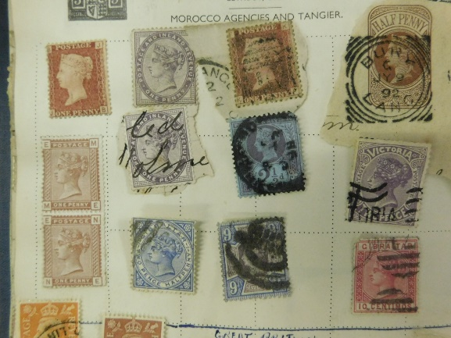
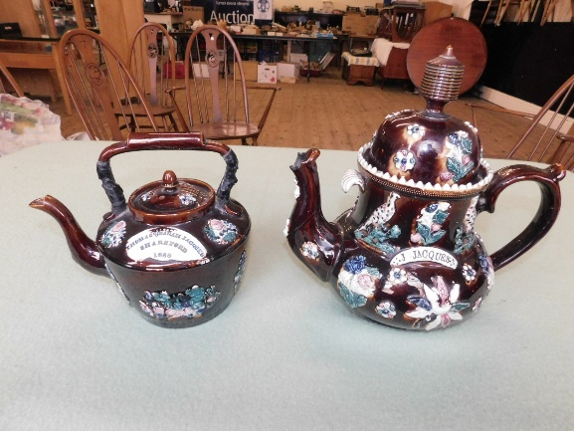
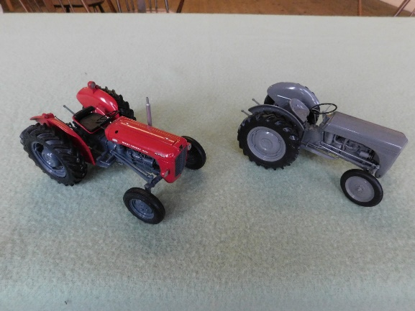
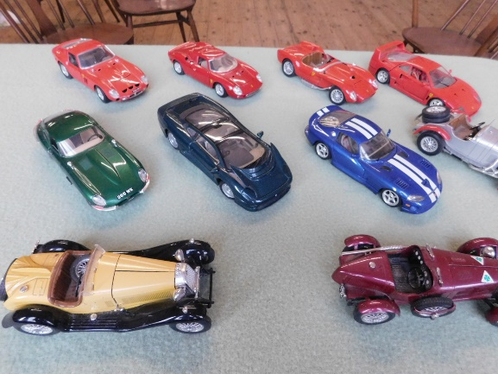
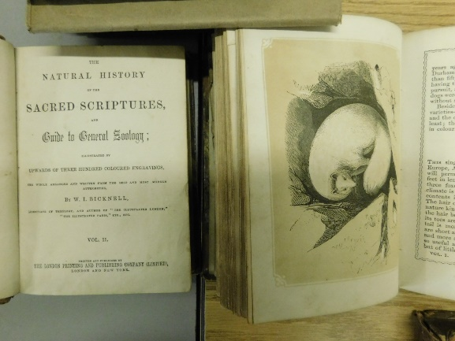
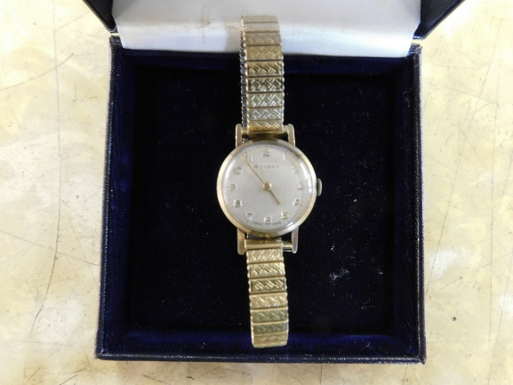
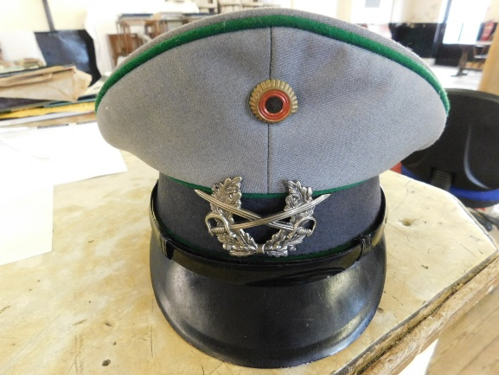
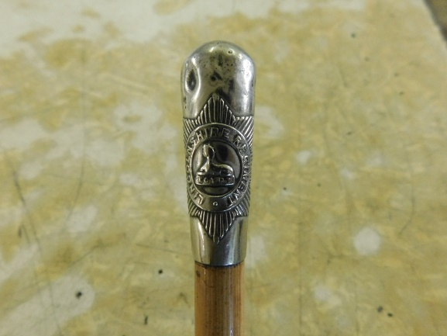
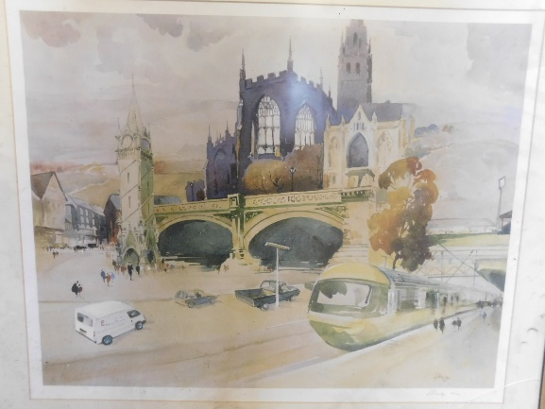

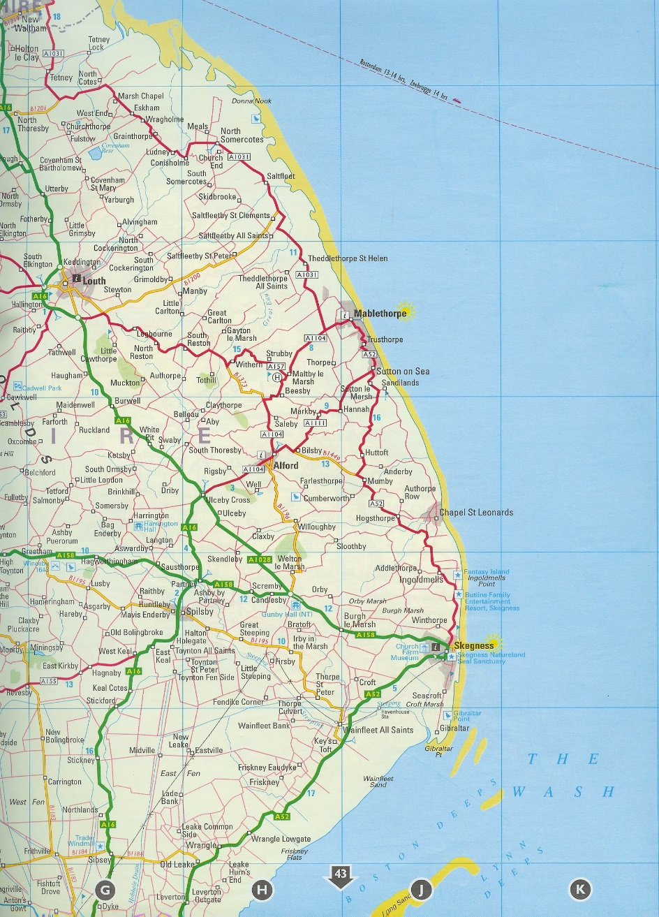
32 ROMAN BANK
SKEGNESS, LINCS
PE25 2SL
T
H
E

M
A
R
T

S
A
L
E
R
O
O
M

http://www.hunters.com/skegness-auctions
jonathan.booth@hunters.com 01754 766061

http://www.hunters.com/skegness-auctions
jonathan.booth@hunters.com 01754 766061

